Streaming

1. DStream-based Spark Streaming (Old / Legacy)
Module:
pyspark.streaming
Example import:
from pyspark.streaming import StreamingContext

>>> What it is:
- Original streaming library (introduced in Spark 1.x)
- Uses RDD-based API (DStreams)
- Processes data in micro-batches

>>> How it works:
- Incoming data → split into small batches → each batch = RDD
- Then you apply transformations (map, reduce, etc.)

>>> When used:
- Older projects
- Need low-level control

>>> Limitations:
- Higher latency (seconds)
- Harder to write complex queries

2. Structured Streaming (Recommended in Spark 2.x)
Module:
from pyspark.sql import SparkSession

>>> What it is:
- Introduced in Spark 2.x
- Built on DataFrame / SQL engine
- Treats stream as a continuous table

>>> Key features:
- Write streaming like normal SQL / DataFrame code
- Supports:
  - Aggregations
  - Window operations
  - Joins
- Fault-tolerant with exactly-once processing

>>> Advantages:
- Easier syntax
- More powerful
- Better performance
- Future-proof (industry standard now)

you can run both batch and streaming code in the PySpark command line (pyspark shell).

1. Run Batch Code in pyspark

>>>Start PySpark shell:
pyspark

>>>Then run:
df = spark.read.csv("data.csv", header=True, inferSchema=True)
df.show()
This works directly because:
- spark (SparkSession) is already created automatically in PySpark shell
2. Run Streaming Code in pyspark

Step 1: Start socket server (NEW terminal)

nc -lk 9999

Step 2: Run in PySpark shell

from pyspark.sql.functions import explode, split
# Read stream
df = spark.readStream \
.format("socket") \
.option("host", "localhost") \
.option("port", 9999) \
.load()

# Process
words = df.select(explode(split(df.value, " ")).alias("word"))
result = words.groupBy("word").count()

# Output
query = result.writeStream \
.format("console") \
.outputMode("complete") \
.start()

Step 3: Type data in terminal
Example:
hello spark
hello world

Important Things (VERY IMPORTANT)

Don’t use:
query.awaitTermination()
It will block your shell

To stop streaming:
query.stop()

In terminal

In Pyspark shell

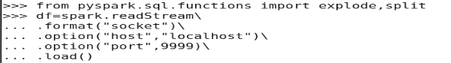

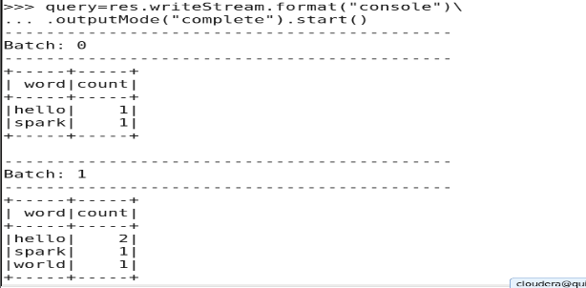
In terminal

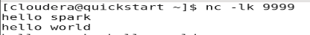

Error count

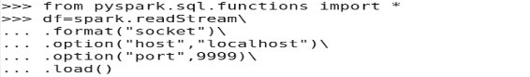

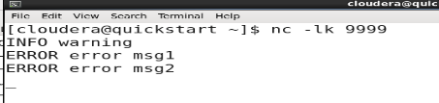

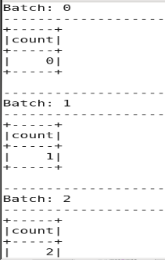
Metastore-all information related to hive stored in metastore

Before spark was known as shark-combination of spark and hive
Hive useful for structured and semi-structured data

